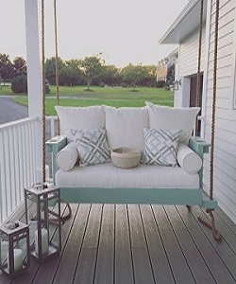

Poliform Swing

$101.30

Avilability: In stock

**Description:**

With immense market knowledge, we have been able to provide optimum quality Swing. The comfortable cushioning of the headboard gives your body all the support needed to sit and relax. Available in multiple colors and sizes. Our wood come in a wide range of stylish variations, including cherry, hickory, maple, birch and red oak. You can feel comfortable.